EXPT NO: 6 | IMPLEMENTATION OF LSTM FOR SENTIMENT ANALYSIS
DATE: 30.09.2026 | IMPLEMENTATION OF LSTM FOR SENTIMENT ANALYSIS

PRE-LAB QUESTIONS (PROVIDE BRIEF ANSWERS TO THE FOLLOWING QUESTIONS)

- What is the purpose of Long Short-Term Memory (LSTM) networks in NLP?
LSTM networks are a type of Recurrent Neural Network (RNN) designed to remember important information from long sequences of text. They are used in NLP tasks such as sentiment analysis, text generation, machine translation, and speech recognition.

- Why is LSTM preferred over a Simple RNN for processing long text sequences?
LSTM is preferred because it can remember information for a longer period and reduces the vanishing gradient problem faced by Simple RNNs. Its memory cells and gates control what information should be stored, forgotten, or passed forward.

- What is sentiment analysis? Give two real-world applications.
Sentiment analysis is the process of using NLP to identify the emotion or opinion expressed in text, such as positive, negative, or neutral.
Applications:
- Analysing customer reviews to understand satisfaction.
- Analysing social media comments to determine public opinion about a product or service.

- Explain the role of tokenization and padding in text preprocessing.
Tokenization is the process of splitting text into smaller units called tokens, such as words or sentences.
Example: “I love AI” → [I, love, AI].
Padding is used to make sequences of different lengths equal in size by adding special padding tokens, usually 0. This allows them to be processed together by neural networks.

- What is word embedding? Why is it useful for sentiment analysis?
Word embedding is a technique that converts words into numerical vectors that represent their meaning and relationships.It is useful for sentiment analysis because words with similar meanings or sentiments have similar vector representations. This helps the model understand words such as “excellent,” “great,” and “amazing” and classify the sentiment more accurately.

AIM
To implement a Long Short-Term Memory (LSTM) network for sentiment analysis by performing text preprocessing, tokenization, sequence generation, and embedding using NLP libraries, and classify text into sentiment categories.

SOFTWARE REQUIREMENTS
- Python
- TensorFlow / Keras
- Google Colab
- GitHub
- NumPy
- Pandas
- Matplotlib
- NLP libraries – NLTK / spaCy
- Scikit-learn

OBJECTIVES
Students will be able to:
- Understand the architecture and working of LSTM networks.
- Perform text preprocessing techniques for sentiment analysis.
- Tokenize and convert textual data into numerical sequences.
- Generate word embeddings for textual data.
- Build and train an LSTM model for sentiment classification.
- Evaluate the performance of the trained LSTM model.
- Analyze the effect of preprocessing and embedding on sentiment classification.

PROCEDURE
PART A: DATASET PREPARATION AND TEXT PREPROCESSING
- Perform the following tasks:
- Load a sentiment analysis dataset such as the IMDB Movie Reviews dataset.
- Explore the dataset and examine sample positive and negative reviews.
- Check the number of samples and sentiment class distribution.
- Perform text preprocessing using NLP libraries.
- Convert text to lowercase.
- Remove unnecessary punctuation and special characters.
- Remove stop words, if required.
- Tokenize the reviews into words/tokens.
- Convert the tokens into numerical sequences using a tokenizer.
- Build a vocabulary from the training reviews.
- Apply sequence padding to obtain equal-length input sequences.
- Encode sentiment labels into numerical form.
- Split the prepared dataset into training and testing/validation datasets.
(CODE: CONATAINS STUDENT ROLL NOS
SCREENSHOT OF CODE
SCREENSHOT OF OUTPUT)

PART B: EMBEDDING GENERATION
Perform the following tasks:
- Generate numerical representations of the pre-processed text.
- Create an Embedding layer using Keras/TensorFlow.
- Define the vocabulary size and embedding dimension.
- Convert tokenized sequences into dense vector representations.
- Display the shape of the generated embedding representation.
- Analyze how words are represented in the embedding space.
(CODE: CONATAINS STUDENT ROLL NOS
SCREENSHOT OF CODE
SCREENSHOT OF OUTPUT)

PART C: IMPLEMENTING THE LSTM MODEL
Perform the following tasks:
- Create an input layer for the padded text sequences.
- Add an Embedding layer to generate dense word representations.
- Add an LSTM layer to learn sequential dependencies in the reviews.
- Add a Dense output layer with an appropriate activation function for sentiment classification.
- Compile the model using:
  - Appropriate optimizer
  - Binary cross-entropy loss
  - Accuracy as the evaluation metric
- Display the model architecture and summary.
(CODE: CONATAINS STUDENT ROLL NOS
SCREENSHOT OF CODE
SCREENSHOT OF OUTPUT)

PART D: MODEL TRAINING AND SENTIMENT PREDICTION
Perform the following tasks:
- Train the LSTM model using the prepared training dataset.
- Validate the model using the validation dataset.
- Record:
  - Training accuracy
  - Validation accuracy
  - Training loss
  - Validation loss
- Visualize:
  - Accuracy vs. Epoch
  - Loss vs. Epoch
- Evaluate the trained model using the test dataset.
- Predict the sentiment of sample reviews.
- Compare the predicted sentiment with the actual sentiment.
- Calculate appropriate evaluation metrics such as:
  - Accuracy
  - Precision
  - Recall
  - F1-score
  - Confusion matrix
(CODE: CONATAINS STUDENT ROLL NOS
SCREENSHOT OF CODE
SCREENSHOT OF OUTPUT)

EXPECTED OUTCOME
Students will understand how LSTM networks learn sequential information from textual data and apply them to sentiment classification. Students will learn to perform text preprocessing, tokenization, sequence padding, and embedding generation using NLP libraries. They will build and train an LSTM model and evaluate its ability to classify reviews into positive and negative sentiments.

CODE:
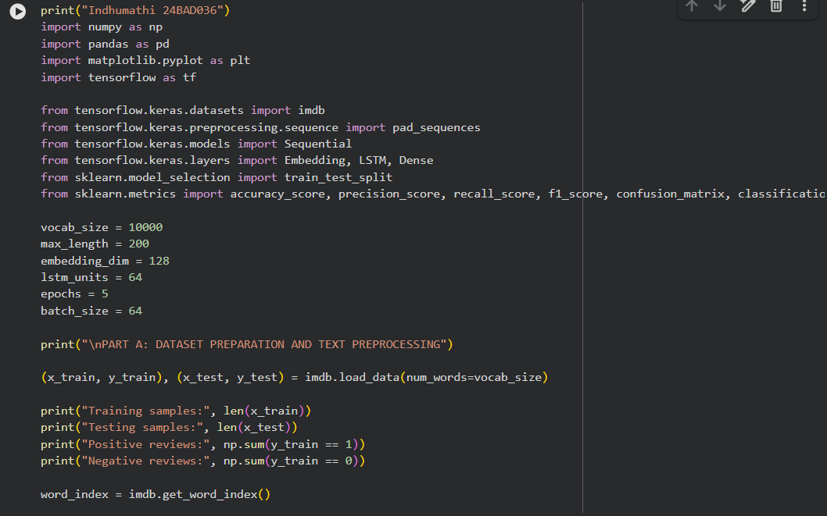

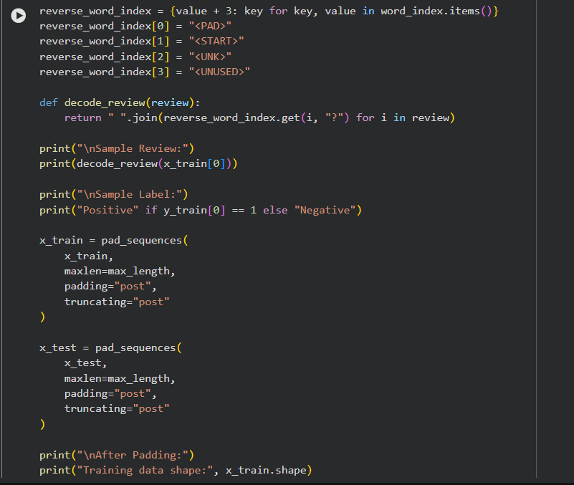
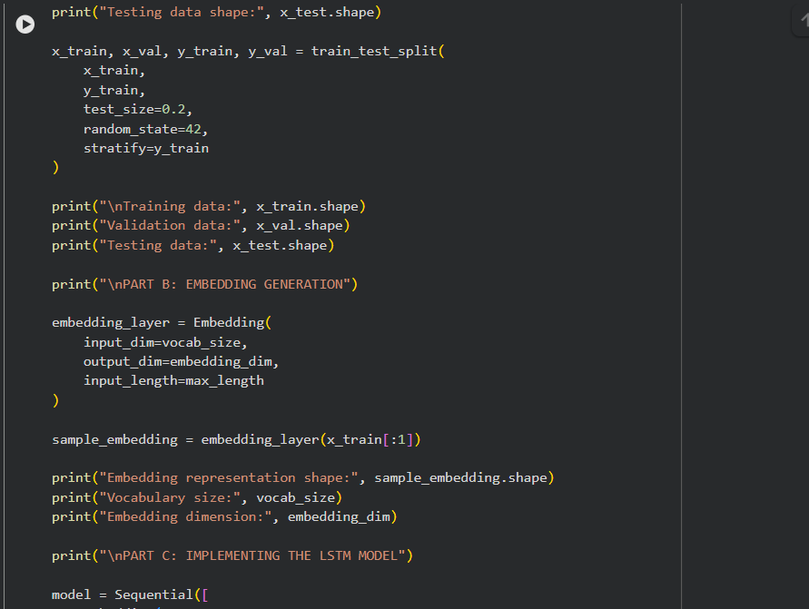
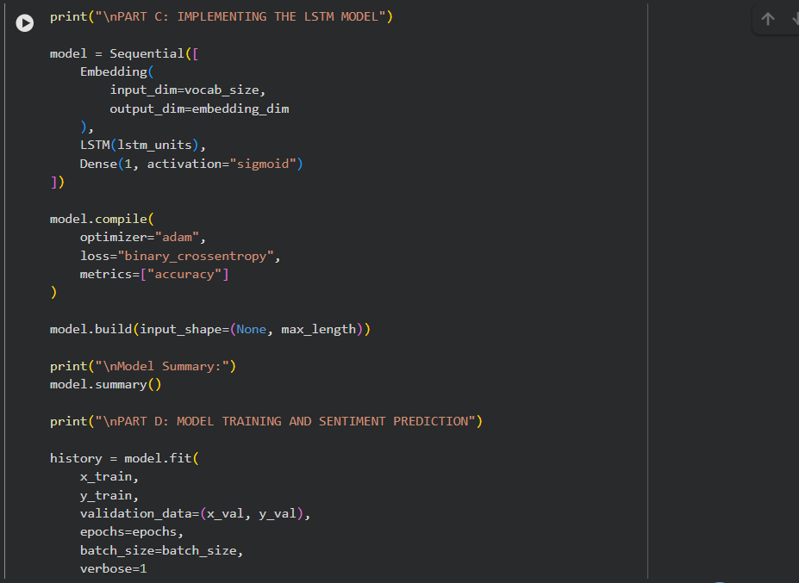
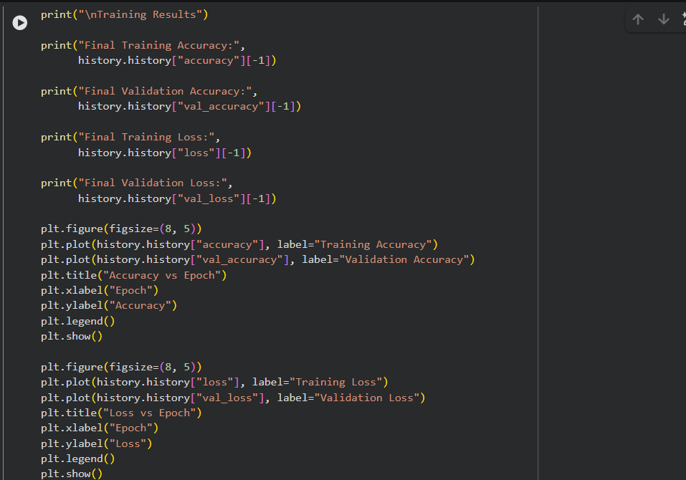
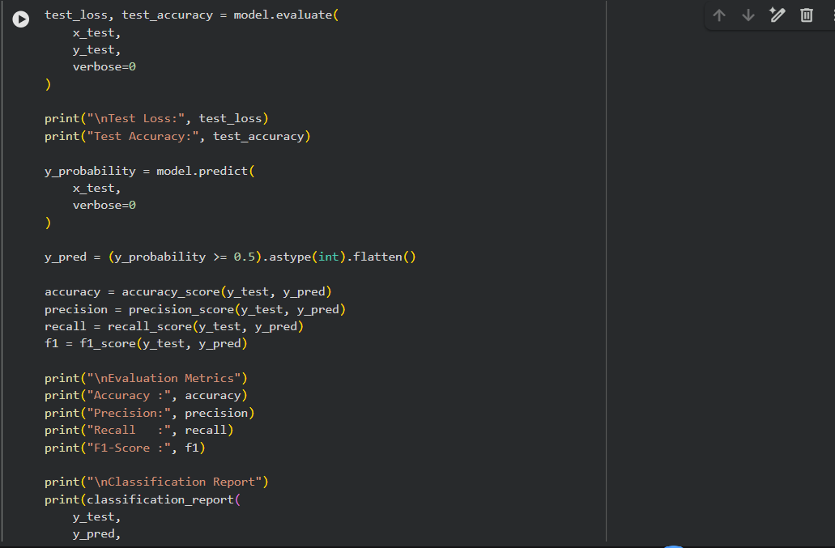
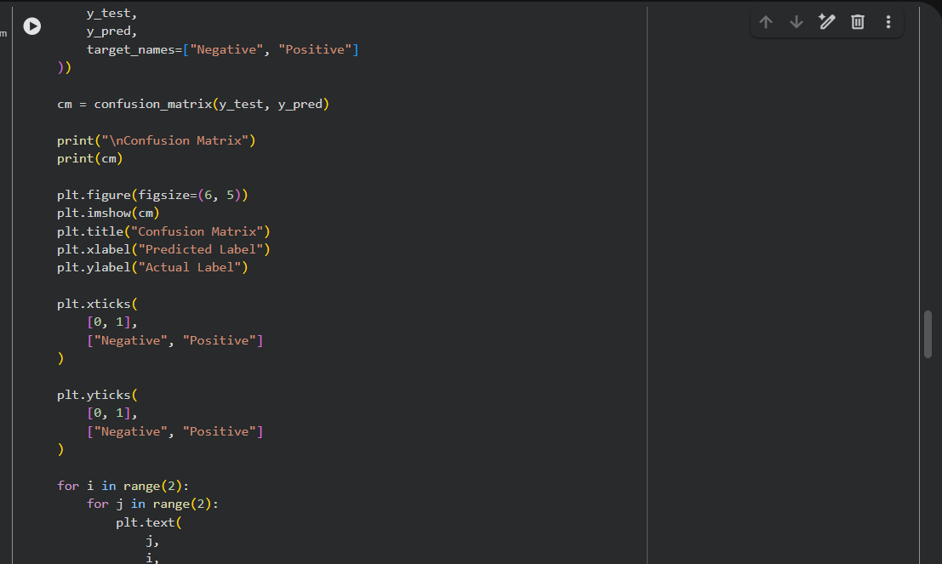
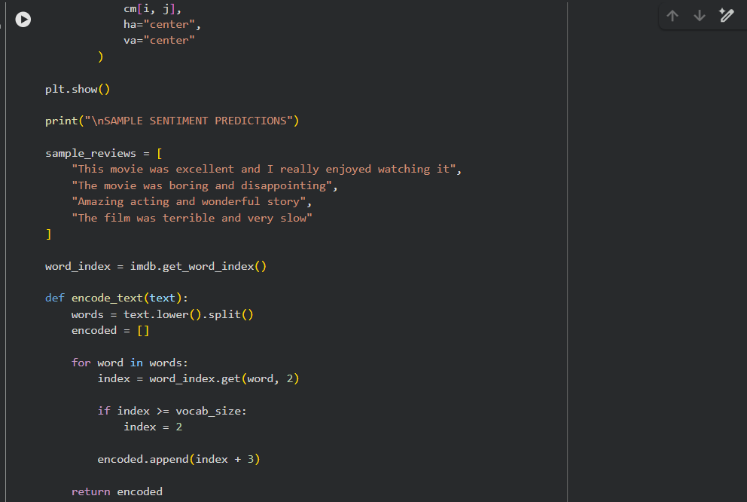
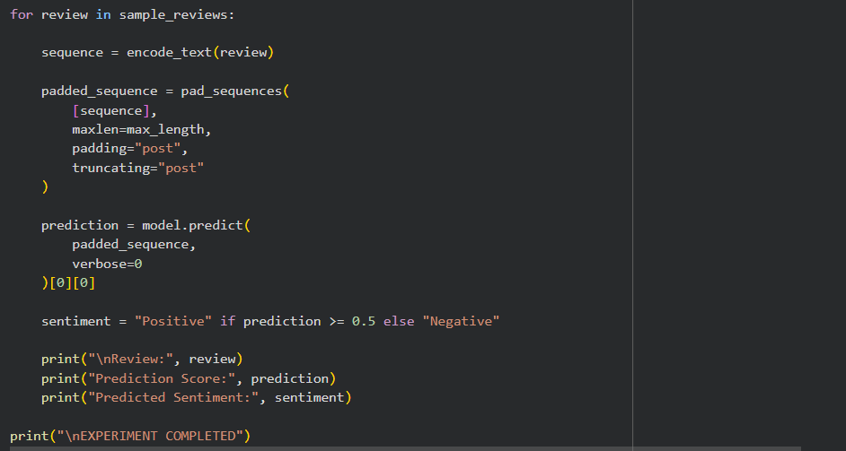
OUTPUT:
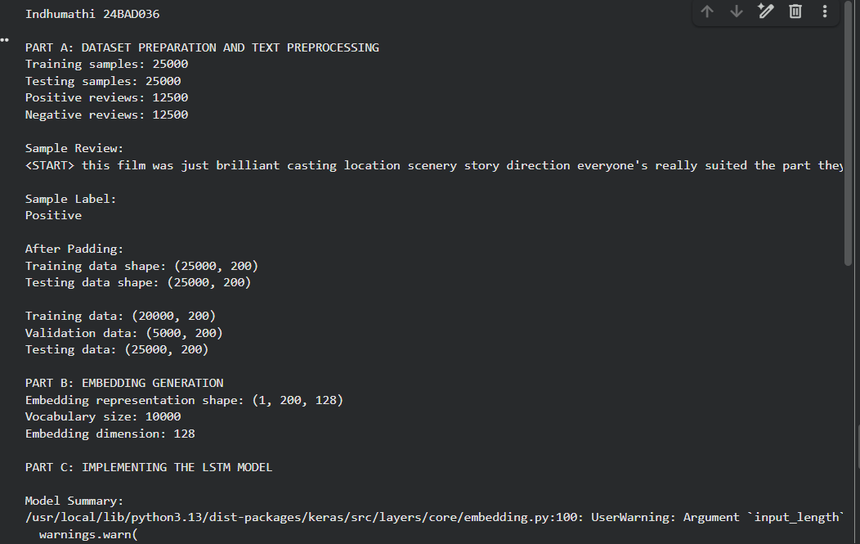
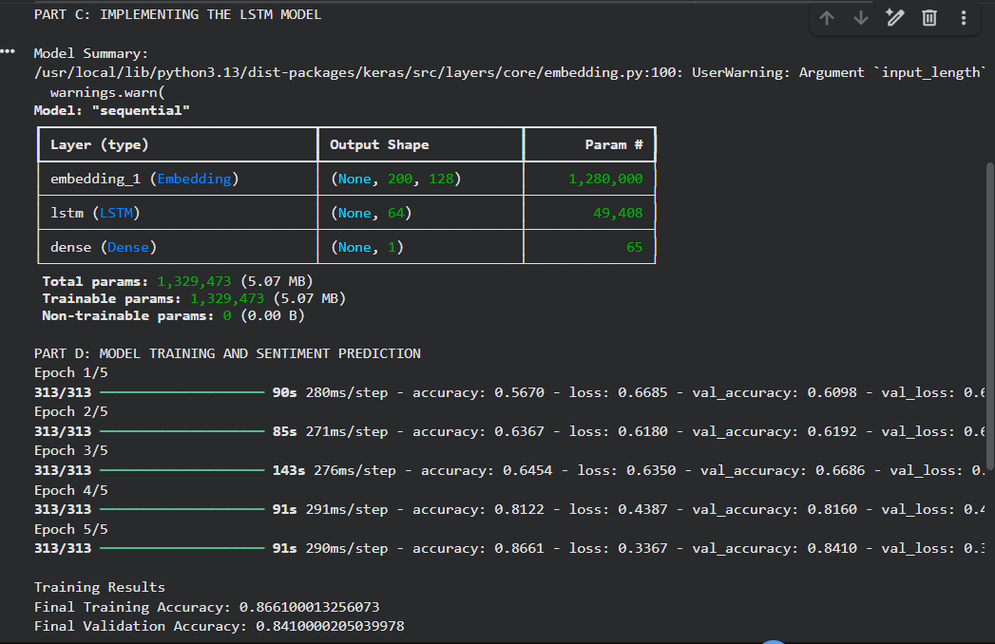
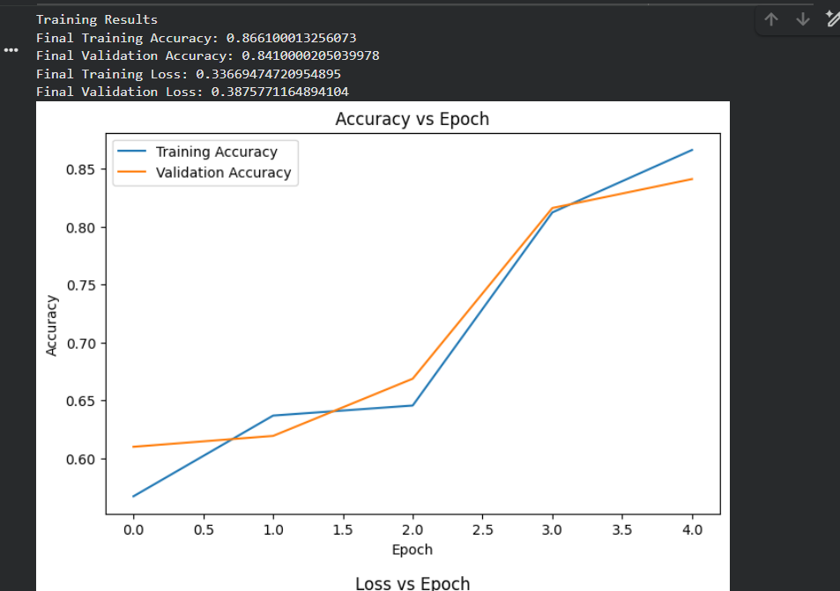
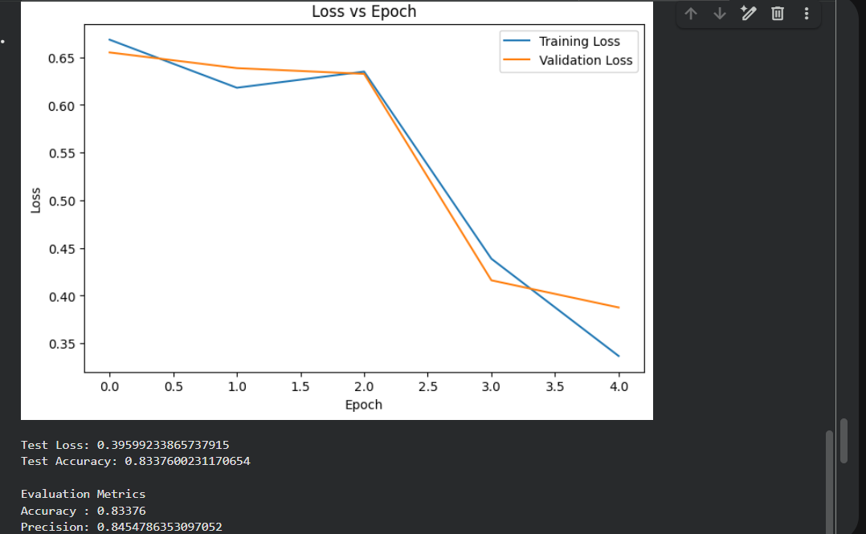
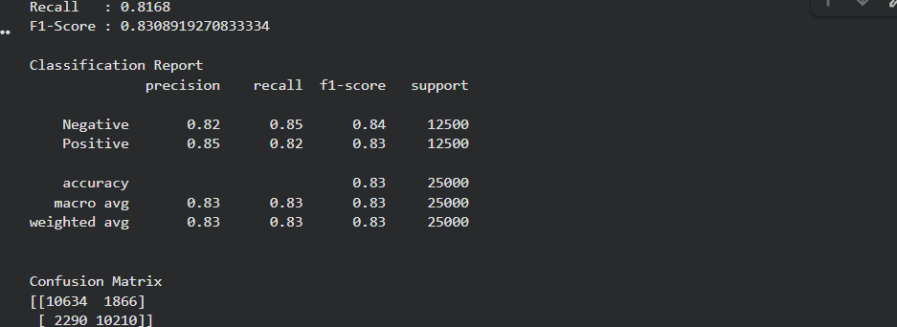
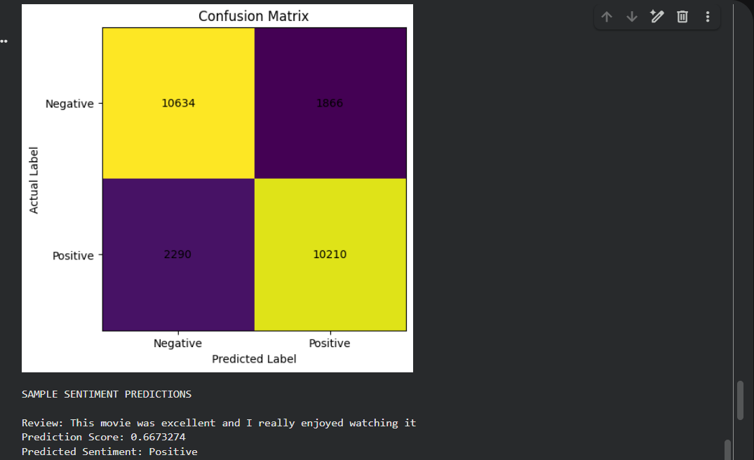
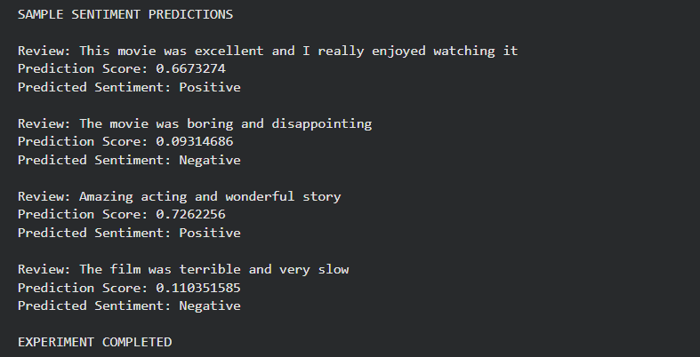

POST-LAB QUESTIONS (PROVIDE BRIEF ANSWERS TO THE FOLLOWING QUESTIONS)

- What is the role of the memory cell in an LSTM?
The memory cell acts as a long-term storage unit in an LSTM. It carries important information through the sequence and allows the network to retain or remove information using its gates.

- What is the purpose of the Embedding layer in the sentiment analysis model?
How does an LSTM overcome the vanishing gradient problem of a Simple RNN?
LSTM uses a memory cell and special gates (input, forget, and output gates) to control information flow. The cell state provides a pathway for gradients to flow over long sequences, which helps reduce the vanishing gradient problem.

- How does padding affect the input to an LSTM network?
The Embedding layer converts words or token IDs into dense numerical vectors. These vectors capture relationships between words and help the LSTM understand the meaning and sentiment of the text.

- What happens when the LSTM model is trained for too many epochs?
Padding makes all text sequences the same length by adding padding tokens, usually zeros, to shorter sequences. This allows multiple sequences to be processed together by the LSTM.

- Why are precision, recall, and F1-score useful in addition to accuracy?
Accuracy alone may not show how well a model handles each class, especially when the data is imbalanced.
- Precision – measures how many predicted positive results are actually positive.
- Recall – measures how many actual positive results are correctly identified.
- F1-score – provides a balance between precision and recall.

- Give one limitation of using LSTM for sentiment analysis.
One limitation is that LSTMs can be computationally expensive and slow to train, especially when processing large datasets or very long text sequences.

SUGGESTIONS FOR DATASETS
- IMDB Movie Reviews – https://ai.stanford.edu/~amaas/data/sentiment/
- SST-2 (Stanford Sentiment Treebank) – https://huggingface.co/datasets/stanfordnlp/sst2
- Twitter Sentiment Analysis – https://www.kaggle.com/c/twitter-sentiment-analysis
- Stanford Sentiment Treebank (SST) – https://huggingface.co/datasets/stanfordnlp/sst
- Amazon Product Reviews – https://huggingface.co/datasets/amazon_polarity
- Yelp Polarity Reviews – https://huggingface.co/datasets/fancyzhx/yelp_polarity

ASSESSMENT
Description | Max Marks | Marks Awarded
Pre Lab Exercise | 5
In Lab Exercise | 10
Post Lab Exercise | 5
Viva | 10
Total | 30
Faculty Signature

